

**ST. RAPHAEL JUNIOR DAY AND BOARDING NURSERY AND PRIMARY SCHOOL.**

**P.O BOX 39, MPIGI**

**CONTACT: +256 705 945 768, +256 704 155 989, +256 773 152 710**

**EMAIL: straphaeljuniorschool12@gmail.com**

**LESSON NOTES READING MIDDLE CLASS**

TERM I - 2024

WEEK 1

CONTENT

ORIENTATION

Activities

Learning and telling news about animals sound around the environment i.e.

cow - moo - moo

goat me me

snake -sss

Week 2

Period 2

Content

Sounding and reading

Activities

* Sounding different sounds
* Sorting different sounds
* Acting upon the actions while acting the actions
* Copying the sounds into their books.
* taking chances in soundings.

Period 2

Content

Formation of simple words using two sounds and matching.

as an in at is

Activities

* Sounding the different sounds
* Forming the simple word
* Sounding and reading the words.
* Matching different simple words.

Period 3

Content

Copying the formed words into books

at an in is as at

__ __ __ __ __ __

Activities

* Sounding the given sounds
* Forming the simple words following the simple words.
* Copying the exercise into their books.
* Acting upon the actions in the sounds.

Period 4

Content

Matching pictures to sounds

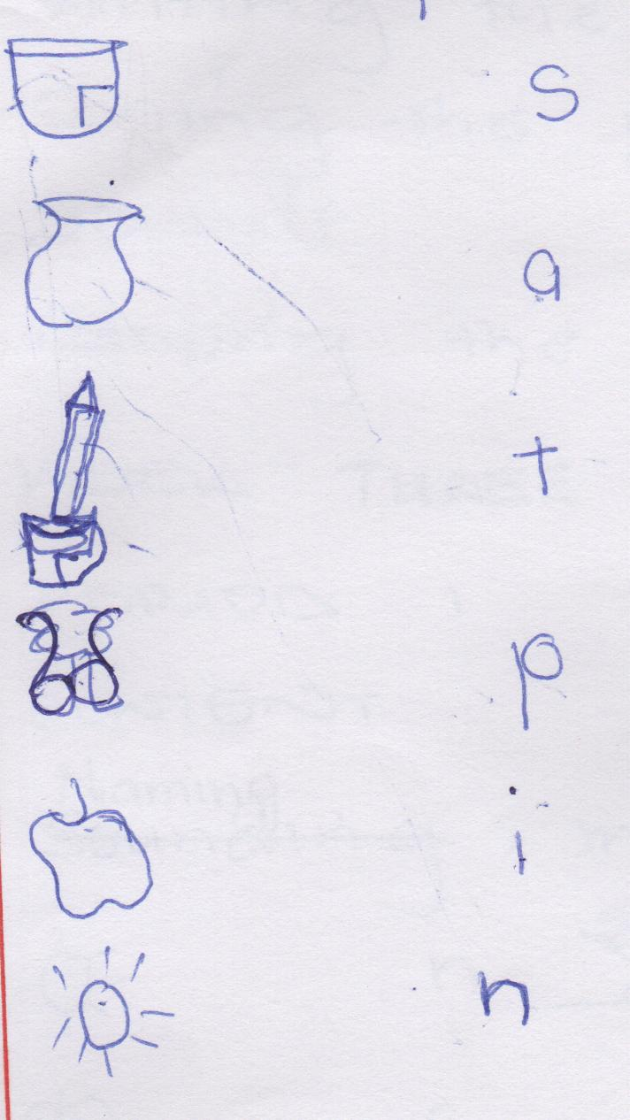s a t I p n

Activities

* Sounding their sounds
* drawing the pictures
* naming and sounding the exercise
* matching pictures to sounds
* copying the exercise into books

Period 5

Content

Writing the beginning sound (starting)

|  |  |  |  |
| --- | --- | --- | --- |
| ant | Tin | pin | sit |
| a | T | _____ | ____ |

Activities

* Sounding the different words
* Forming the words
* Writing the starting sound
* Sorting the given sounds from other sounds
* Copying the exercise into books.

Week 3

Period 1

Content

Naming, matching and drawing

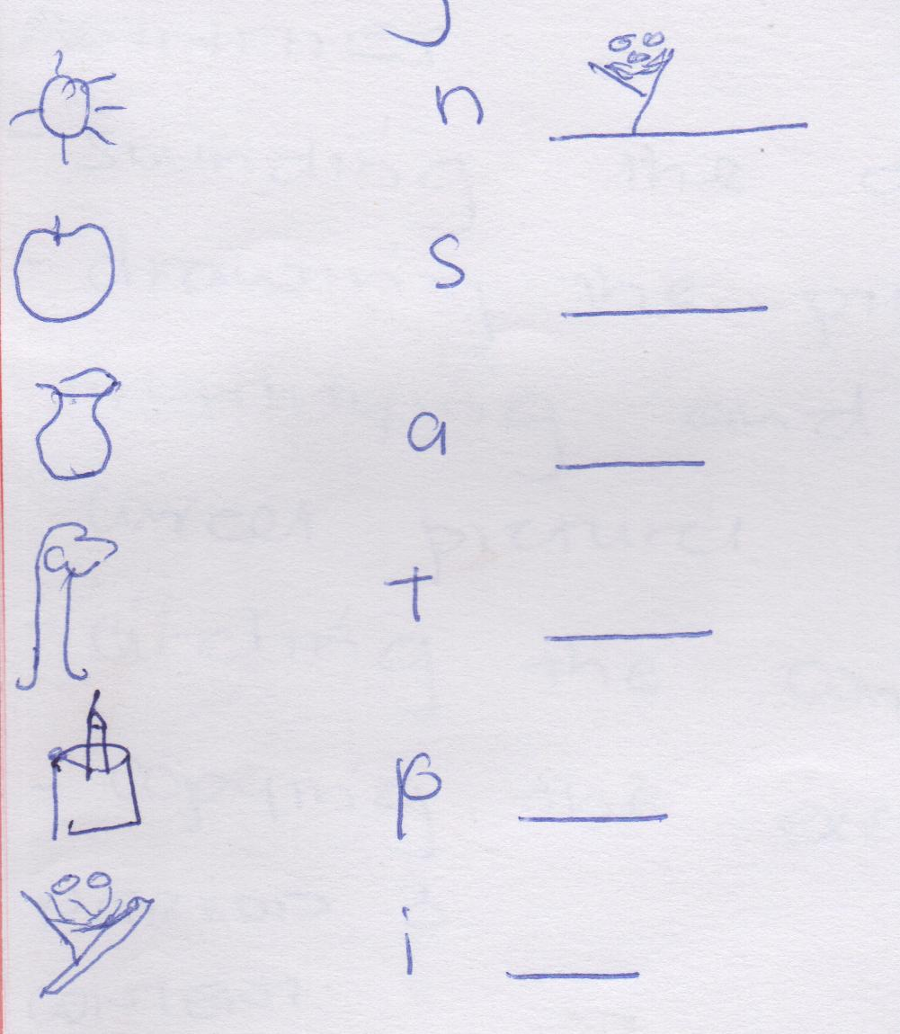

Activities

* Sounding the sounds
* Drawing the pictures
* Naming the sounds orally pictures.
* matching pictures to sound
* Copying the exercise into their books.

Period 2

Content

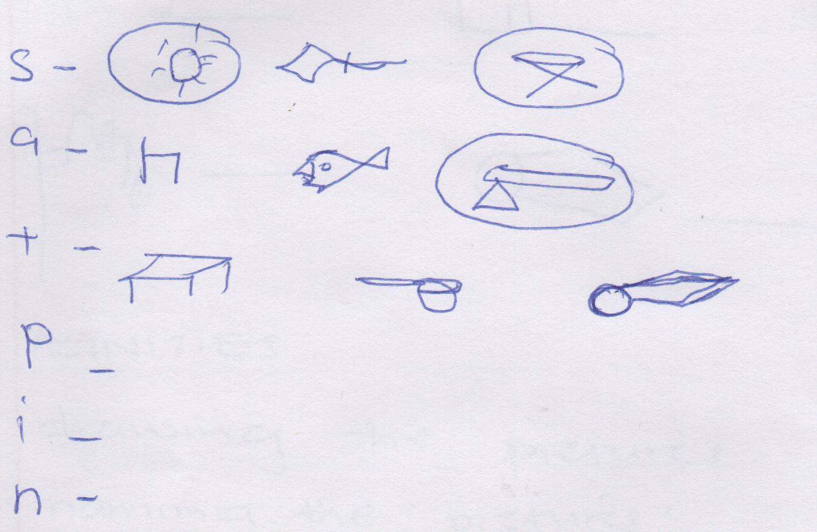Sounding and circling the pictures for the sounds given.

Activities

* Sounding the different sounds
* Drawing the pictures given
* Identifying and recognizing the correct pictures for the sounds.
* Circling the correct pictures
* Copying the exercise into books

Period 3

Content

Reading and drawing

* It is a tin _______________
* It is a tap ______________
* It is a pin _______________
* It is a pan ________________
* It is a pot _________________

Period 4

Content

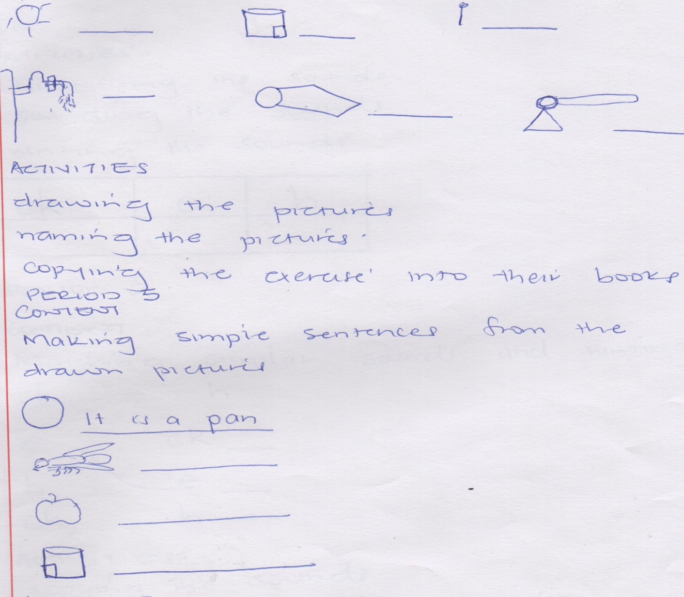Naming different pictures drawn.

Activities

* Drawing the pictures
* naming the pictures
* Copying the exercise into their books.

Period 5

Content

Making simple sentences from the drawn pictures

It is a pan.

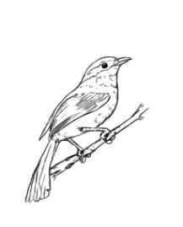 _____________

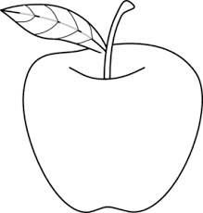 ______________

______________

Activities

* Drawing the pictures
* Sentence writing in books
* Sounding the sentences in groups and individuals
* Copying the exercise into books.

Week 4

Period 1

Content

Introducing the second level of jolly phonics

ck e h

Activities

* Identifying the sounds
* Sounding the sounds
* Writing the sounds

|  |  |  |
| --- | --- | --- |
| Ck | e | h |
| ___ | ___ | __ |

Period 2

Content

Matching similar sounds and writing

ck e h

e ck ____

h e ____

ck h _____

Activities

* Copying the sounds
* Matching the similar sounds
* Writing the sounds
* Copying the exercise into books.

Period 3

Content

S a t i p n pen, pin, hen, his, ant

Formation of simple sentences

i.e. it is a pen.

Activities

* Identifying the simple sentences
* Forming the simple sentences
* Sounding the formed sentences
* Copying the exercise into books

Period 4

Content

r m d

Activities

* Sounding the given sounds
* Naming the sounds
* Sorting the sounds

Period 5

Content

m r d

Sounding and matching

m

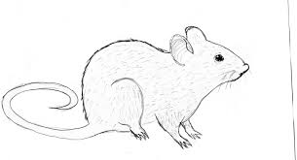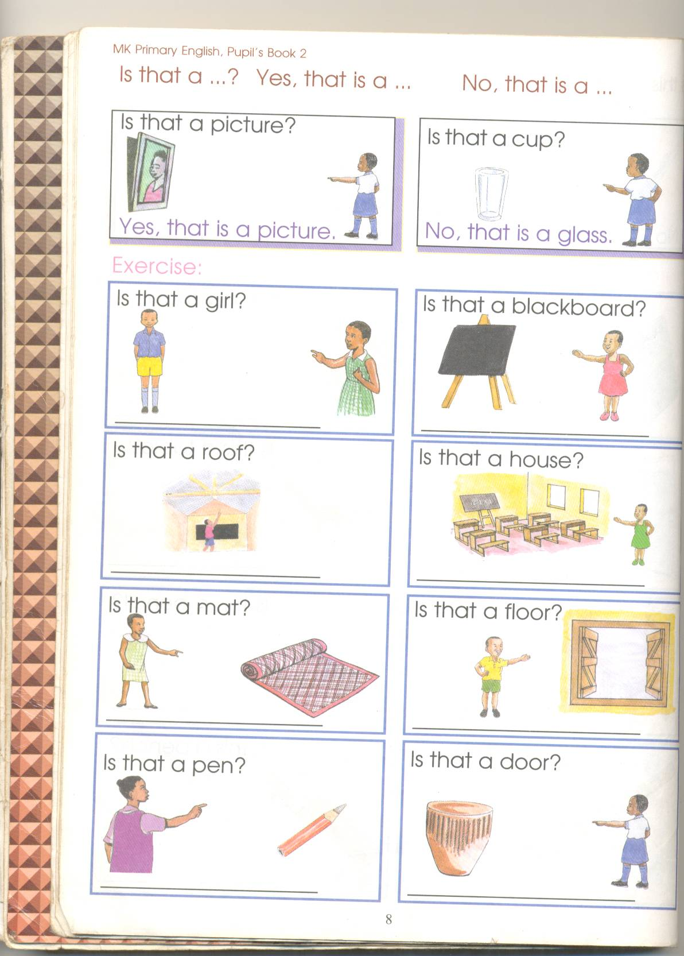r

d

Activities

* Sounding
* Naming
* Sorting
* Matching sound to picture
* Copying the exercise into books
* Drawing the pictures

Week 5

Period

Content

Introducing the vowels

a e i o u

__ __ __ __ __

__ __ __ __ __

__ __ __ __ __

Activities

* Sounding repeatedly
* Tracing the vowels
* Copying the exercise into books

Period 2

Content

Formation of syllables using a

ba ca da ma na ra

fa ga ha ka la

Activities

* Formation of syllables
* Reading the syllables
* Copying the syllables into their books.

Period 4

Content

Formation of simple words using the syllables and sound.

ba-t = bat ba-g = ____ ca-t = _____

fa-n = ____ ha-t = ____

activities

* Sounding the syllables
* Forming words
* Sounding the formed words
* Copying the formed words into books

Period 5

Content

Formation of sentences and drawing.

* It is a bag __________
* It is a cat ____________
* It is a fan ______________
* It is a hat ______________
* It is a tap ______________

Week 6

Period 1

Content

Forming syllables using e

be-d = bed ge-t = __________ he-n = _____

pe-n = ____ le-g = _______ je-t = _____

Activities

* Forming words
* Sounding the words formed
* Copying the exercise into books
* Following the instructions

Period 2

Content

Matching pictures to words

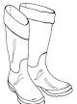net

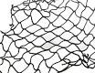pencil

hen

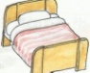leg

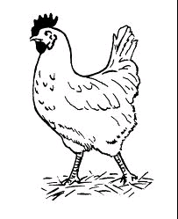bed

Activities

* Forming of words
* Reading the words
* Drawing and matching
* copying the exercise into their books

Period 3

content

Making simple sentences

It is a hot

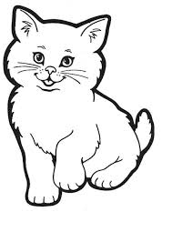

_________________



___________________

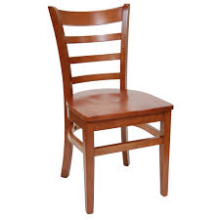

__________________

Activities

* Drawing the pictures
* making simple sentences
* Reading simple sentences
* Copying the exercise into their books.

Period 4 - 5

Content

Telling sounds

g o u / I f b

Activities

* Copying the sounds into books
* Sounding the different sounds.
* Sorting the given sounds
* Following the instructions given

Week 1 & 2

g l u f o o

Ringing the pictures for the sounds given

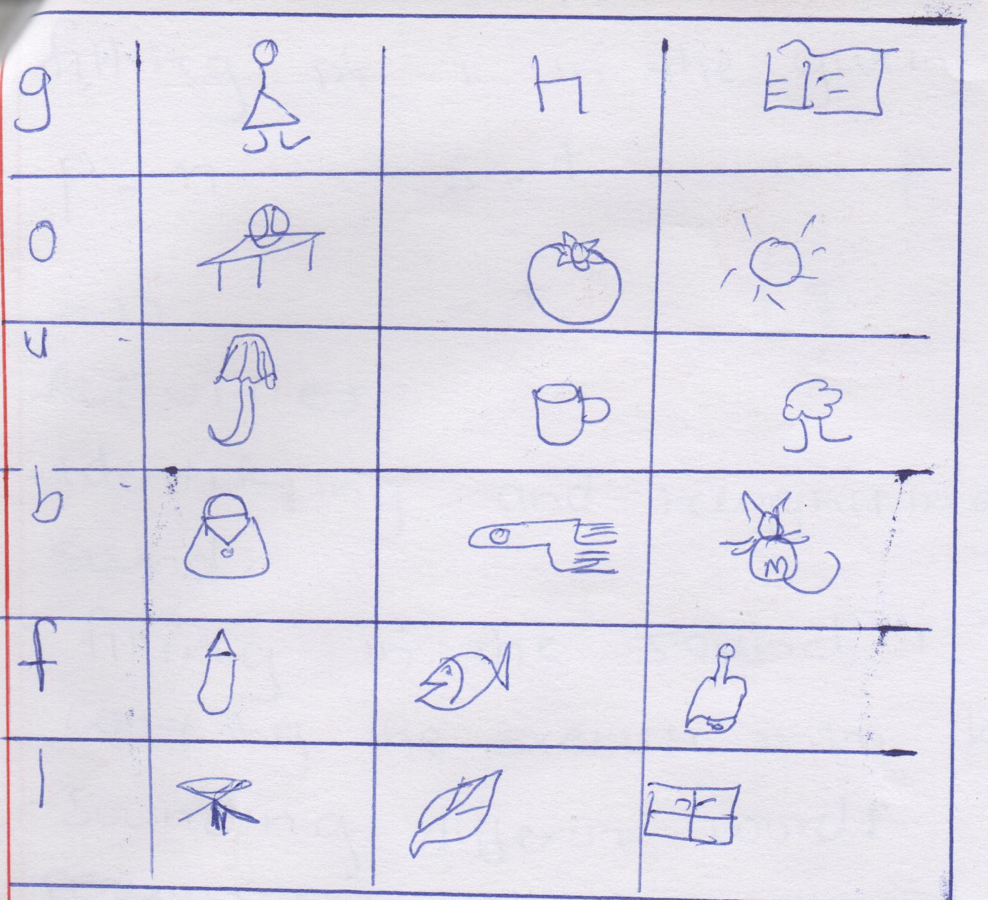

Period 3

Content

Formation of simple words

du-ck _________ sun = ___________

ne-ck __________ gu-n _____________

ga-te __________ ro-pe _____________

Activities

* Sounding the syllables
* Forming words
* Joining the syllables to form words
* Sorting different words.

Period 4

Content

* Forming words using

Filling in I in the given sound

p – n s – t n – p t – n

- n - t is

Activities

* Identifying and recognizing the given sound.
* Filling in the sound
* Copying the exercise into books

Period 5

Content

Forming syllables with ‘o’ sound and making words i.e.

lot __________ po-p ___________ fo-g _________ ho- t ____

to-y __________ fo-x ___________ do-g __________

Activities

* Forming the syllables
* Sound the word
* Copying the exercise into books
* Using the materials given
* Following the instructions while sorting

Week 8

Period 1

Content

Forming simple sentences and drawing

It is a red toy ___________

It is a big fox _____________

A pot and a dog ____________

It is a hot tin. ____________

Let him sit on the bed. ________

Activities

* Sounding the word
* Copying the exercise into book

Period 2

Content

Complete the sentences (using pen, duck, pot, ball, cup)

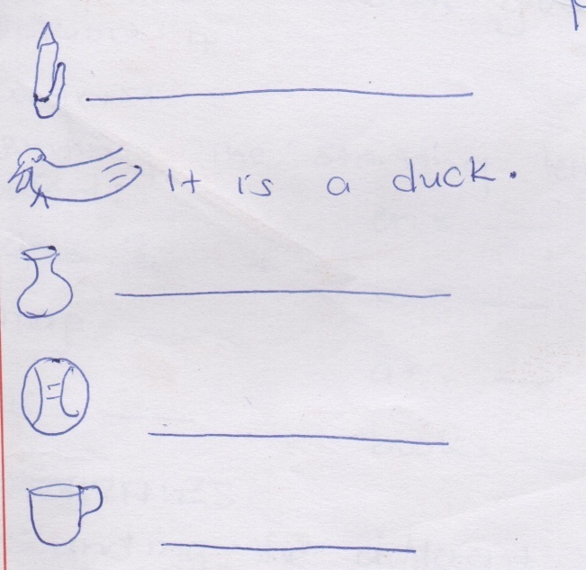

Activities

* drawing the pictures
* Completing the sentences
* Copying the exercise into books
* Sounding the sentences
* Using the materials given.

Period 3

Content

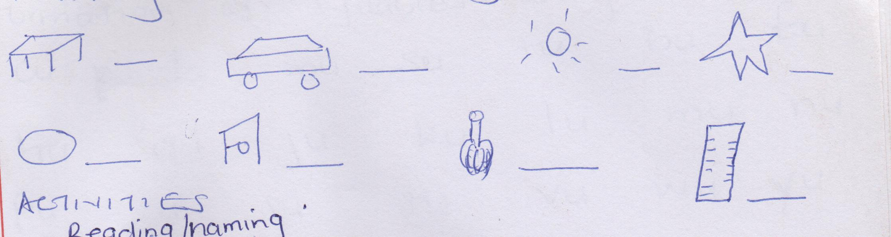Writing the starting sound.

Activities

* Reading /naming the given pictures
* Writing the starting sound.
* Naming the given exercise
* Copying the exercise given.

Period 4

Content

Writing the starting sound using words.

an - a on - ____

map - ______ in - ____

as - ______ book - _____

Activities

* Sounding the different words.
* Writing the starting sound
* Copying the exercise into their books.
* Sounding the starting sound.
* Sorting the materials given.

Period 5

Content

Formation of syllables using sound U.

Cu- du mu tu bu fu zu

hu gu ju ku lu mu nu

pu ru su tu vu wu yu

Activities

* Forming the syllables
* Copying the exercise
* Sounding the formed syllables
* Using the materials given.

Week 9

Period 1

Content

Formation of words using sound U

cu-p = su-n du-ck gu-n

hu-t - ___ bu-s - _______ bu-m -_____ ru-n - ____

Activities

* Sounding the given words
* Copying the exercise into their books.
* Forming words individually
* Using the materials given.
* Following the given instructions.

Period 2

Content

Reading and drawing

* It is a gun ______________
* It is a bus ______________
* It is a hut _______________
* It is a cup _______________
* It is a mug ______________

Activities

* Sentence writing by individuals
* Sounding the words / sentences given
* Copying the exercise into their books.

Completing the sentences with a correct word.

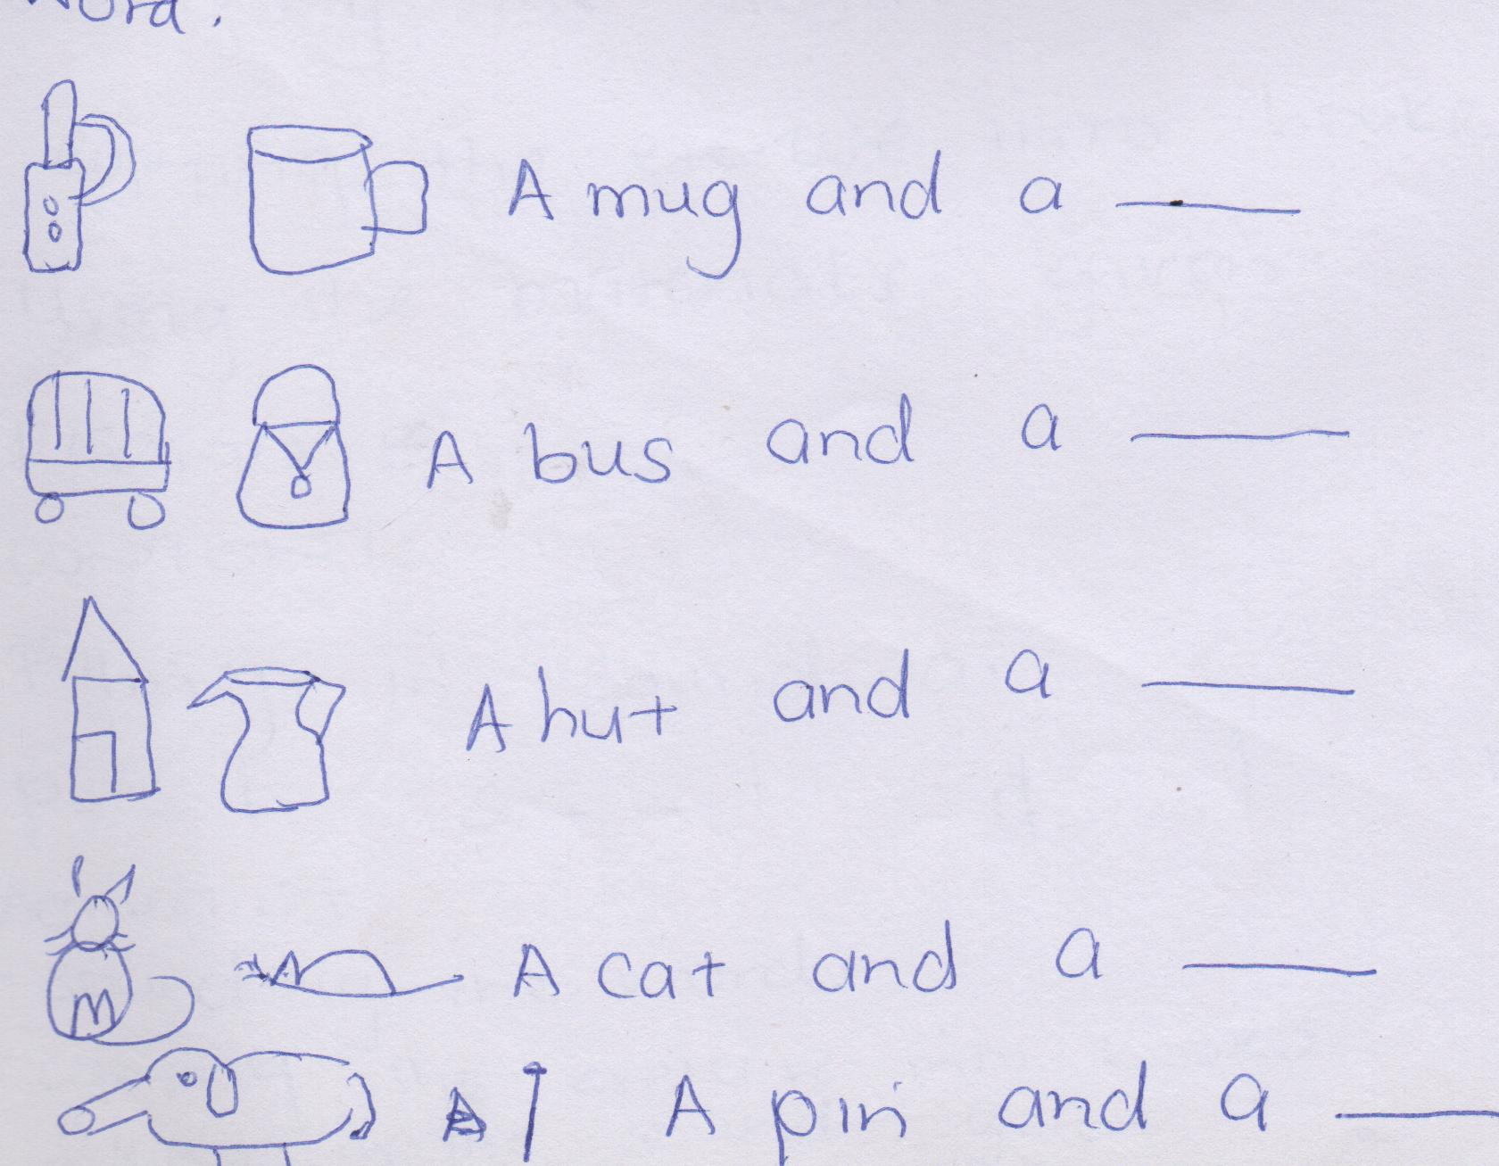

Activities

* Drawing the pictures
* Forming the sentences
* Completing the sentences
* Sounding the sentences
* Copying the exercise into their books.

Learning and sounding sound ai

train pain dail mail

zain maid maize nail

Activities

* Forming the words
* Sounding the different words
* Copying the exercise into books.
* Using the materials given.

Filling in sound ai

p - - l s _ _ l d _ _ l n _ _ l

Activities

* Sound the words
* Copying the exercise into books
* Filling in the sound given.

Term II, 2020

Week 1 PD1

Content:

Reading the syllables.

ba ca ta ga

ha ja ka ma

Activities

* Reciting the given letter sounds.
* Reading the given syllables
* Joining the syllables
* Reading the formed words.

Period 2

Content:

Forming words.

ba – ck = _________________ fa – t = _____________________

no –se = __________________ ma –t = _____________________

Activities

* Reading the formed words.
* Joining the syllables to the sound to form a word.
* Sounding and reading the words.
* Forming the simple words.

Period 3

Content:

Reading and drawing pictures.

* It is a hat
* it is a cat
* it is a bag
* it is a mat

Activities

* Drawing the pictures
* Sentence writing in books
* Sounding the sentences in groups and individuals.
* Copying the exercise into books.

Period 4

Content

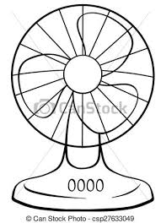Naming the pictures.

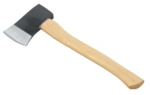

------------------ -------------- --------------

Activities.

* Reading the given syllables ba, ca, fa, ha,
* Reciting the given letter sounds.
* Joining syllables to a sound to form words.
* Writing the names of the pictures.

Period 5

Content

Making sentences for the pictures.

* ……………………………………………



* …………………………………………





Activities

* Making sentences in the pictures.
* Recognizing drawn pictures.
* Reciting the pictures names orally.
* Sounding the pictures.

Week 2:

Period 1: Content

Circle the words for sound ‘a’

* air pail nail maid
* axe tail cat
* air hat fan
* hair bag train
* man main mat

Activities

* Reciting the given sound.
* Pronouncing words with sound.
* Reading words with sound.

Period 2

Underline for sound ‘a’

* chair cat chart
* mat main man
* zip zain box

activities

Reading words with ‘a’

Underline for the given sound.

* Pronouncing words with sound ‘a’
* Recognizing and identifying words.

Period 3: content

Tick for the sound given ‘a’

 net nail

train tap

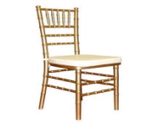

chair cat

Activities

* Reciting the given sound ‘a’
* Recognizing the drawn pictures.
* Pronouncing the written words.
* Tick for picture given.

Period 4: Content

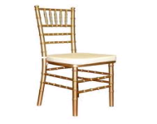Naming the pictures.

 ---------------------------

-----------------------

---------------------------------

Activities

* Reciting the given sound.
* Recognizing the drawn pictures.
* Naming the pictures given.
* Writing the names of the pictures.

Period 5: Content:

Forming words for the sound.

1. i –r = air.

ra-in = _____

ch- ai-r = ______

za- in = ______

Activities

* Sounding the syllables.
* Forming words.
* Sounding the formed words.
* Copying the formed words into books.

Week 3

Period 3: Content:

* Jug jump jik
* jacket jean juice

Circle the same.

Jug ear jug

jet jump jump

jean jean jet

Activities

* Pronouncing words with sound j
* Circling the same words.
* Reading words with sound

Period 2: Content

Reading and matching for the sound.

jug jim

jump jack

jim jug

jack jump

Activities

* Reciting the letter sound
* Reading words with sound j
* Matching the same words.
* pronouncing words with sounds.

Period 3: Content

Read and draw pictures.

* Here is a jug
* Her is a jacket
* Her is a chair

Activities

* Reading the structure ‘here’
* Drawing pictures for the given sentences.
* Sounding the given words.

Period 4: Content

Completing the sentences.

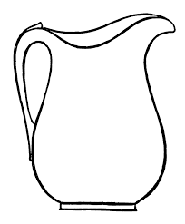

Her is a ……………….



Here is a ………..

Activities.

* Naming the pictures orally.
* Reading and completing the sentences.

Period 5: Content

Making sentences for the pictures.

Here is a chair. ----------------------------------------------

-----------------------------------------------

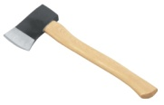

-------------------------------------------------

Activities:

* Recognizing the pictures.
* naming the pictures orally.
* Making sentences for the pictures orally.
* Writing sentences for the pictures.

Week 4

Period 1: Content:

Forming words for the syllables.

g = bag il = _____

ba ba

t = _________ nk = ______

sket = ___________

ba nglow = _________

Activities:

* Sounding the given words.
* Copying the exercise into their books.
* Forming words individually.
* Using the materials given.
* Following the given instructions.

Period 2

Content: Read and draw.

boat ___________________ coat ________________

goat ___________________ bag ________________

bat ____________________

Activities:

* Reciting sounds.
* Pronouncing sounds.
* Reading the given words with sounds.

Period 3: content.

Fill in the missing letters or sounds.

c a t g _ _ t tra _ n co _ t

Activities.

* Reciting sounds given to fill in
* Reading words with sounds.
* Identifying and filling in the missing sounds.

Period 4: Content

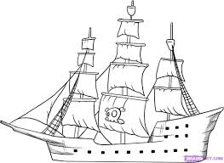Complete the sentences.

That is a …………….

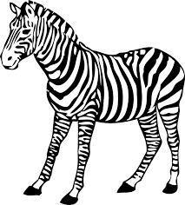

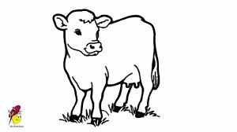 That is a ……………..

That is a ---------------------

Activities

* Recognizing the drawn pictures.
* Reading the structures.
* Reading and completing the sentences.

Period 5: Content:

Read and draw.

That is a boat.

That is a loaf

That is a cow.

Activities.

* Reading the given structures.
* Reading the given sentences.
* Drawing pictures for the given sentences.
* Making sentences.
* Writing sentences.

Week 5

Period 1: Content

Make sentences for the given pictures.

That is a book.



…………………..

Activities:

* Recognizing and naming the drawn pictures.
* Making sentences for the pictures.
* Writing sentences.

Period 2: Content

Reading words with sounds

pie tie lie die

Circle the same words.

tie tin tie

die die dig

lip lie lie

Activities

* Reciting the given sound.
* Pronouncing words
* Reading words with sounds.
* Circle the same words.

Period 3: Content

Fill in the missing sounds.

P _ e b _ _ t t _ _ L _ _ f

Activities

* Reciting sound.
* Reading words with sound.
* Identifying and filling in the missing sound.

Period 4

Read these sentences.

* Here is a red tie.
* Here is a pie
* Her is a boat
* A mad man has a tie

Activities

* Reciting sounds.
* Reading the given structure.
* Reading the given sentences.

Period 5

Forming words.

n = ___________

Fa t = ____________

t = ___________

po

rk = _____________

Activities:

* Following the given instructions.
* Using the materials.
* Copying the exercise into their books.
* Reciting sounds given.

Week 6

Period 1 : content:

Fill in the sounds ‘ee’ or ‘ie’

F - - t tr _ _ t _ _

Activities

* Reciting the given sounds.
* Pronouncing the words with sound ‘ee’
* Identifying and filling in the missing sounds.
* Reading the formed words.

Period 2: Content

Read and draw pictures.

* I can see a bee ………………
* I can see a tree ………………
* I can see a tie. ……………….

Activities :

* Reading the given word.
* Making sentences.
* Drawing the pictures for the given sentences.

Period 3: content:

Make write words with sound ‘ee’ and ‘ie’

ee = bee , ____________

ie = tie , ___________

Activities

* Reciting the given sounds.
* Mentioning words with sound.
* Writing words with sound.

Period 4

Tick the same words.

Worm doctor worm

Fork fork fan

Word word orange

Activities

* Pronouncing the given words.
* Tick for the word given same.
* Reading the given words.
* Recognizing the drawn pictures and naming.

Period 5: Content

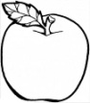Circle the correct word.

orange tie

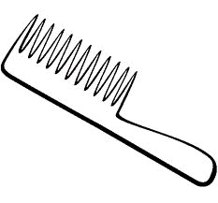

fat fork

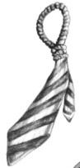

tin tie

Activities

* Reading the given words.
* Recognizing drawn pictures and naming them orally.
* Circle the correct words.
* Spelling the words.
* Identifying the given words.

Week 7

Period 1 Content:

Completing the sentences.

This is a fork.

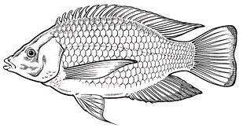 This is a _____________ This is a ---------

Activities:

* Reading the given structures.
* Reading the given sentences.
* Naming the pictures orally.

Period 2: content:

Make good sentences.



………………….. ……………………..

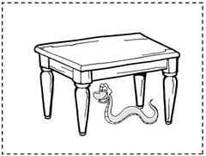

…………………..

Activities:

* Recognizing the drawn pictures.
* Naming the pictures orally.
* Making sentences.

Period 3: Content

Form word

nk = bank mel = _____

ba ca

sket ____ ndle = ____

Activities:

* Reading the given syllables.
* Forming words.

Period 4: Content:

Form words.

n ____

bu cket ____

at ______

bo rn ________

Activities:

* Reading the formed words.
* Forming words.

Period 5 Content:

Read the sentences

* That is a doctor.
* That is an orange.
* That is a fork
* Jill has a tie.

Activities.

* Reading the given sentences.
* Reading and drawing pictures for the given sentences.
* Reading the given structure.

Week 8

Period 1 : content:

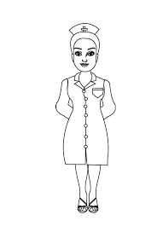Make sentences.

That is a doctor

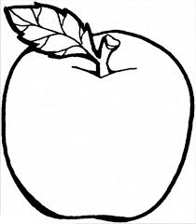

--------------------------------------

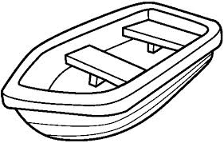

……………………………..

Activities

* Recognizing drawn pictures.
* making sentences orally.
* Reciting the given sound.

Period 2

Content:

Reading sound words.

Zip, zebra zain zero

Zone zoom zig-zig

Activities:

* Reciting the given sound.
* Pronouncing the given words.
* Reading the given words.

Period 3: Content:

Zig-zig zebra

Activities

* Pronouncing words with sound.
* Reading the given words.
* Reciting the given sounds.

Period 4 : Content.

* It is a bee.
* That is a boat.
* That is a zoo.

Activities.

* Reciting the given words.
* Reading and drawing pictures for the given sentences.
* Reading the given structures.
* Pronouncing words.

Period 5: Content.

Make good sentences.

----------------------------------------------------------------

----------------------------------------------------------------



-----------------------------------------------------------------

Activities:

* Recognizing the drawn pictures.
* Making sentences for the drawn pictures.
* Writing sentences for the drawn pictures.
* Identifying the pictures.
* Reading the words.